Name: V.Siri Chandana
Roll No: 2520030609
Section:2
Subject:OS
SKILL PROGRAMS:
1.
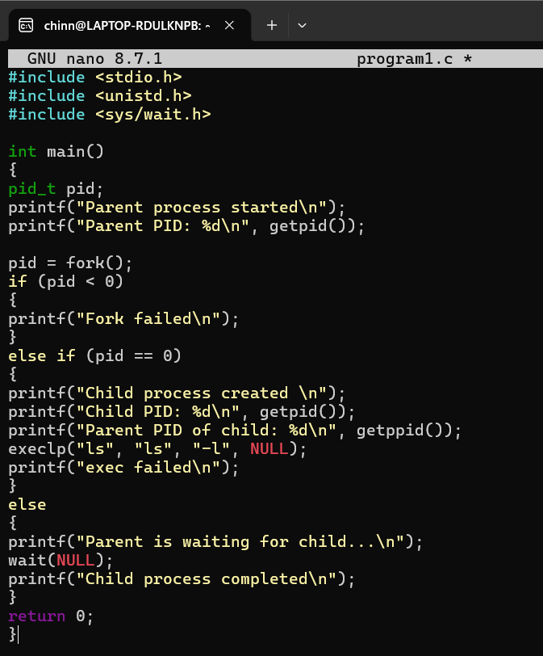

Output:
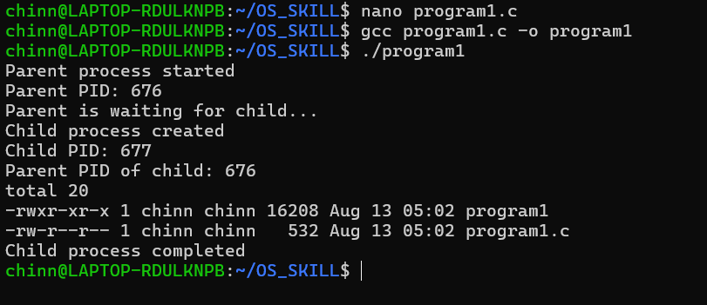
2.
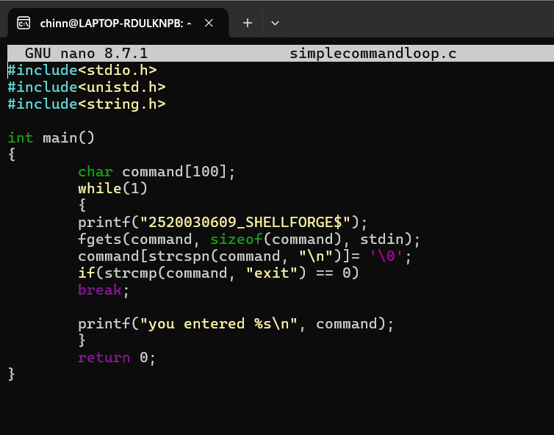

Output:
